**Terms**

* High Availability
* Fault Tolerant: Fault tolerance is the property that enables a system to continue operating properly in the event of the failure of one or more faults within some of its components



* Redundant: No longer needed for a job and therefore out of work.
* Service: What Cloud Services Provider offers?
* Resource: Using Service what we create is Resource.

**Global Infrastructure of AWS**

* AWS identifies a geographical location which is referred as region.
* The infra is hosted on Availability Zones (AZ).
* Every Region is AWS has atleast 3 AZ’s

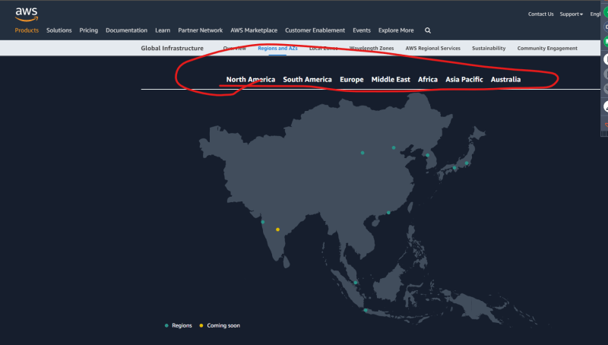

**Virtual Machines on AWS**

* AWS allows us to create VMs by using a Service which is referred as EC2 (Elastic Compute Cloud) Link: <https://docs.aws.amazon.com/ec2/index.html>
* EC2 Service has different Options for realizing your applications.

**EC2 Options**

* Choosing the Right VM Size for the right purpose
  + Instance Families and Instance Types
* Choosing the Right OS for your needs
  + Image => Amazon Machine Image
* Choosing the Right Block Storage
  + Block Storage => EBS (Elastic Block Storage)
* Choosing the network connectivity
  + Public and Private Network
  + Which AZ Ec2 instance should be running
* Choosing the right pricing model <https://calculator.aws/#/>
  + On-demand
  + Reservations
  + Spot Pricing